4th January 2023

Dear Parents and Carers,

Welcome back to Oystercatcher Class and happy New Year to you all. We hope that you had a lovely Christmas break.

Please find attached a curriculum web for this half term, with an overview of what we will be covering in each subject. Our curriculum driver this half term will be Ancient Egypt.

During this project your child will learn about the ancient Egyptian civilisation in detail, to discover how crucial factors like water sources and farming helped them to develop and thrive. They will find out about important inventions and the growth of cities. They will also study the lives of different people in society, including the roles of kings and pharaohs. The children will reflect on their learning by identifying the similarities and differences between civilisations, before learning about the causes and consequences of the Egyptian civilisation’s decline. They will also consider whether or not this civilisation left a lasting legacy.

Reading
As a school, we request that every child reads at home to an adult or older sibling at least 5 times a week. This can be as little as 10 minutes, but regular reading is crucial to becoming more fluent readers. Reading records and books are required in school daily.

Once your child has finished reading their book, they will be asked to complete a short quiz. This is a short quiz of 5-10 questions which monitors their comprehension and understanding of the text and its vocabulary. Once complete, the children will be helped to select a new book within their reading level. Reading records are collected on Monday by the class teacher, please record all the reading your child has completed. We hope to see children quizzing every 2-3 weeks.

Maths
Year 3 programme of study

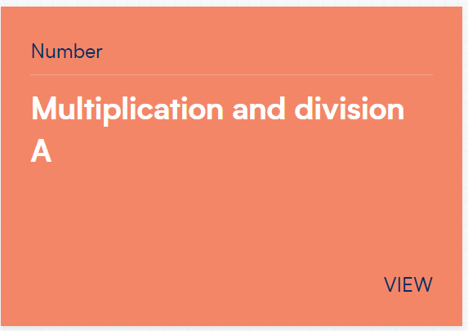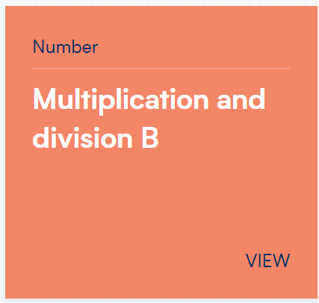

Year 4 programme of study

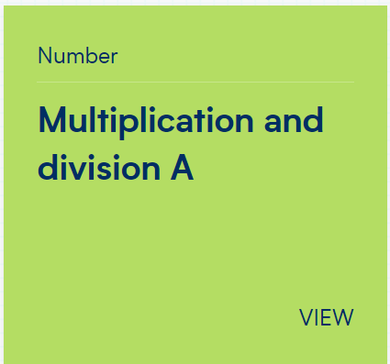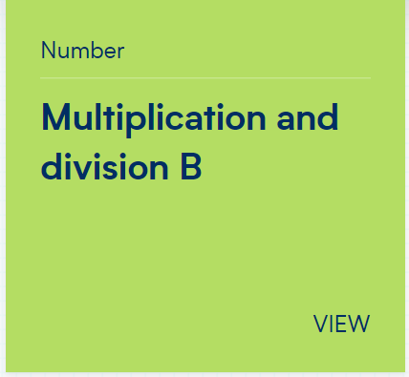

Multiplication
During the summer term, the year 4 children will take part in the National Multiplication check. We will continue to spend time preparing the children for this. As part of this preparation, all children will come home with multiplication flash cards. Once your child can answer the multiplication with instant recall (without needing to recite the table) they will be given the next set to learn.
Year 3 focus this half term – 3, 4 and 8 times tables.
Year 4 focus this half term – 3, 6, 7, 11 and 12 times tables.

We will continue to use ‘Times tables rockstars’ to help improve the children’s fluency. This is an app that can also be accessed from home (details have been sent but please ask if you need further support). We ask that the children given the opportunity to access this regularly at home on a tablet or laptop.

Spellings
We are focussing on spelling rules this term. See the spellings homework grid supplied. The Common Exception words for year 3 and 4 are again on the reverse of the grid.

Each child will have a Spelling & Grammar Book in which these weekly spellings should be practised. Children will need to use their selected spellings to write a sentence. The class teacher will let the children know the grammar focus each week with homework guidance. These homework books will be checked weekly, on a Friday, to ensure spellings are being learnt correctly. Spelling and Grammar books are required in school daily.

PE
PE kit needs to be in school every day. Lessons will be on Thursday this half term as we are swimming for a whole week on week 3. The Thursday session will be dodgeball and orienteering. Please ensure all kit, including shoes, are clearly labelled. As the weather starts to get cooler, we ask that your child has a PE jumper. Jogging bottoms can be worn. All items should be plain black with NO logos or images. A polite reminder that children are not to wear PE kits into school, except for swimming week.

If you have any questions or concerns regarding this information or anything else, please do not hesitate to catch us after school. Should you wish to have a longer appointment, please either telephone or email the school on hello@padstowschool.org to arrange a meeting.

Important dates/information:
Week beginning 16th January – Swimming week.
Thursday 26th January – Penryn Outdoor learning day.

PE lessons – Every Thursday.
Homework due – Every Friday.

Friday 10th February – School Closure Teacher Training Day.

Yours sincerely,
Miss D Richards and Miss S Webster
Class Teachers

