 |  | Autumn |  |  | Spring |  |  | Summer
Cormorant 2023 – 2024 | HISTORY | Anglo-Saxons & Vikings  Vicious, savage, and brutal. Does this tell the whole story of the Dark Ages? |  |  | Local history study  Fantastic Females of Cornwall |  |  | Benin  What led to the rise and fall of the Benin Empire? (until 1900)
 | GEOGRAPHY | SUSTAINABILITY  Connected Geography Enquiry Question:  How can we live more sustainably? |  |  | FRAGILE FORESTS  Connected Geography Enquiry Questions:  Why are jungles so wet and deserts so dry? |  |  | MEGA CITIES  Connected Geography Enquiry Questions:  Why do so many people in the world live in megacities?
 | English | Fiction  The Boy, The Mole, The Fox and The Horse by Charlie Mackesy  Non-Fiction  Instructions: How to survive a Viking quest (GS)  Poetry  Still I rise by Maya Angelou |  | Fiction  Narrative  The lost Thing by Shaun Tan  Poetry  Written and performance  I asked the little boy who cannot see - Anon | Fiction  Narrative Setting Description - The Rainforest  Non-Fiction  Non-Chronological Report: The Amazon Rainforest  Poetry  Riddles |  | Fiction  Character Description: The Beast of Bodmin Moor (GS)  Non-Fiction  Persuasive Leaflet: Visit Falmouth/Padstow  Poetry:  Sick – Shel Silverstein | Fiction  Children of the Benin Kingdom – Dina Orji  Non-fiction  Biography: David Attenborough by Maria Isabel Sanchez  Poetry  The Highway Man – Alfred Noyes |  | Fiction  The great Chocoplot by Chris Callaghan  Non-Fiction  Persuasive leaflet: Visit Mexico
 | Whole Class reading Book  (X2 GR sessions) | 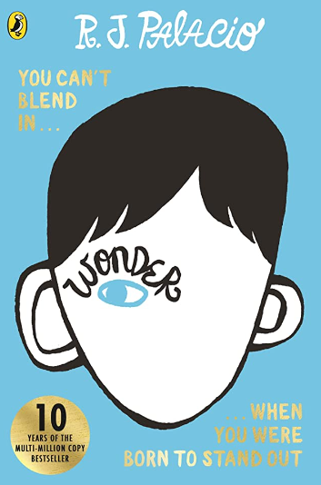  WONDER |  | 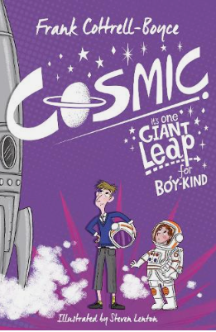  COSMIC | 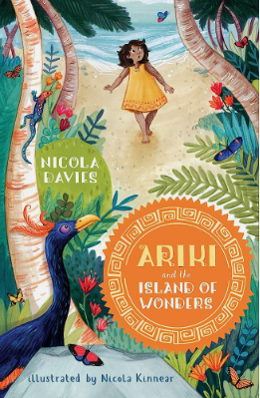  ARIKI & THE ISLAND OF WONDERS |  | 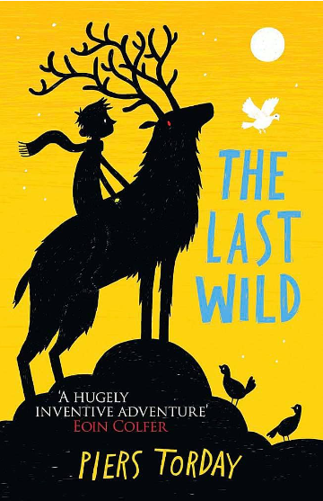  THE LAST WILD | 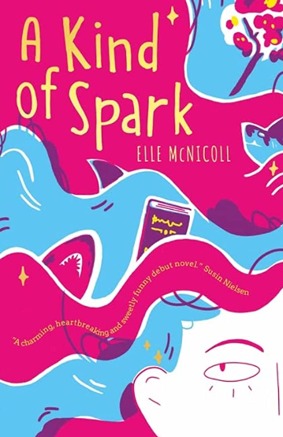  A KIND OF SPARK |  | 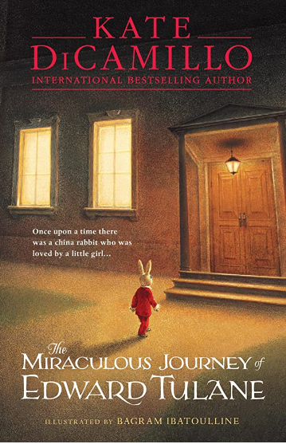  THE MIRACULOUS JOURNEY OF EDWARD TULANE
 | Science | FORCES AND MAGNETS |  | SPACE | CHANGING STATES / MATERIALS |  | ANIMALS INCLUDING HUMANS | LIVING THINGS AND HABITATS |  | ELECTRICITY
 | Art and Design | DRAWING: Experiment with ways in which surface detail can be added to drawings. Use sketchbooks to collect and record visual information from different sources. Draw for a sustained period of time at an appropriate level. |  | PAINTING: Experiment with different effects and textures inc. blocking in colour, washes, thickened paint creating textural effects Work on a range of scales e.g. thin brush on small picture etc. Create different effects and textures with paint according to what they need for the task. | PRINTING: Create printing blocks using a relief or impressed method Create repeating patterns Print with two colour overlays |  | TEXTILES: Use a variety of techniques, e.g. printing, dyeing, weaving and stitching to create different textural effects Match the tool to the material Develop skills in stitching, cutting and joining Experiment with paste resist. | 3D and SCULPTURE: Join clay adequately and construct a simple base for extending and modelling other shapes Create surface patterns and textures in a malleable material Use papier mâché to create a simple 3D object |  | COLLAGE: Experiment with a range of collage techniques such as tearing, overlapping and layering to create images and represent textures Use collage as a means of collecting ideas and information and building a visual vocabulary
 | Design and Technology | Design and make a devise to hold and pour water |  |  | Design and make a structure (model) for living in the rainforest. |  |  | Textiles: Design and make a felt case.
 | Computing | The internet: Computer systems and contexts | Audio Editing: Digital Media |  | Data Logging: Data and Information | Digital Media |  | Repetition in Shapes: Programming A | Repetition in Games: Programming B
 | Curriculum Enrichment | Viking experience day – Under the Canopy |  |  | Geography/History Field Trip |  |  | CAMPS
 | Maths | White Rose Maths |  |  | White Rose Maths |  |  | White Rose Maths
 | RE | What does it mean if Christians believe God is holy and loving? | What does it mean to be a Muslim in Britain today? |  | Why do Christians believe Jesus was the Messiah? | Why is the Torah so important to Jewish people? |  | Christians and how to live: “What would Jesus do?” | What matters most to Humanists and Christians?
 | Music | Musical Instruments / Exploring feeling when you play |  |  | Musical Instruments / Make you feel my love |  |  | Musical Instruments / Dancing in the street
 | PE | Gymnastics  Handball | Football  Swimming/Dance |  | Netball  Fitness | Hockey  OAA |  | Tennis  Athletics | Rounders  Athletics
 | French | See French Scheme: Key Stage 2 French Curriculum Map.docx
 | PSHE | Me and my relationships | Valuing Difference |  | Keeping myself safe | Rights and Responsibilities |  | Being my best | Growing and changing

